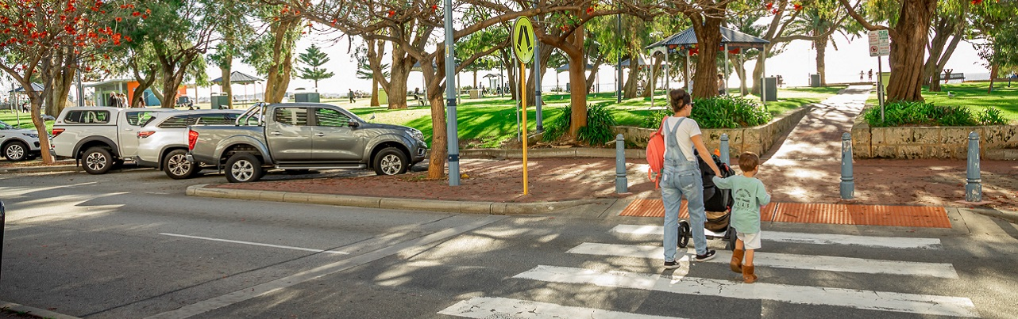

**Guideline for Applying for Children’s Crossing**

2023/2026

City of Rockingham

# 1. Introduction:

The City of Rockingham is regularly approached by schools, parents and concerned residents regarding the safety of school students. The City aims to provide a safe road environment for all students accessing schools within the City; however, pedestrian safety around schools is a complex issue with many factors that need to be considered when identifying solutions to safety issues.

One solution that is often considered is the installation of a children’s crossing which is manned by a cross walk attendant to enable students to cross roads safely. However, the application process is complex and can be difficult to understand. The City has developed this guide to assist schools in completing the application as well as providing further information on the process once the application is approved.

# What is a Children’s Crossing?

A children’s crossing is a warden or guard controlled crossing point which assists students crossing roads by a warden or guard stopping traffic to give pedestrians priority over traffic. The crossing is generally attended by wardens during the school hours of 7.30 – 9.00 am and 2.30 – 4.00 pm. To make the process fair and equitable across Western Australia the approval of children’s crossings is controlled by the Children’s Crossing and Road Safety Committee (CCRSC). The CCRSC is autonomous with its decision-making process, but reports to the Hon. David Michael Minister for Road Safety.

There are two types of children’s crossings Type A and Type B. Type A children’s crossings have wardens supplied by the WA police; whereas, Type B children’s crossings require a warden to be supplied by the applicant.

# The Process:

## Step 1 – Get an Application Form

Application forms are available from the WA Police website:  
[police.wa.gov.au/Traffic/Road-safety/Childrens-crossings](https://www.police.wa.gov.au/Traffic/Road-safety/Childrens-crossings)

## Step 2 – Site Survey

Applicants (principal or president of School’s P and F Association) are required to undertake informal counts of pedestrians (recording primary, secondary and other pedestrians separately), as well as light vehicles (cars, utes, motorcycles etc.) and heavy vehicles (for example trucks) at the nominated location(s) using the survey count forms contained in this application pack. These surveys will enable the applicant to determine the suitability of their application based on the minimum warrant requirements. One AM completed survey count form and one PM completed survey count form must be submitted with the application.

|  |  |
| --- | --- |
| Primary School | Type ‘A’ may be provided where a minimum of 20 students and 200 vehicle movements occur within the hour immediately before and immediately after school, for a primary school, or a combined primary/high school. |
| Type ‘B’ may be provided where a minimum of 10 students and 100 vehicle movements occur within the hour immediately before and immediately after school, for a primary school, or a combined primary/high school. |
| High School | Type ‘A’ may be provided where a minimum of 20 students and 700 vehicle movements occur within the hour immediately before and immediately after school, for a high school. |
| Type ‘B’ may be provided where a minimum of 10 students and 350 vehicle movements occur within the hour immediately before and immediately after school, for a high school. |

# Application review by the City of Rockingham

The children’s crossing application will need to be submitted to the City of Rockingham for review. The City needs to sign off on the application as any infrastructure changes that may be required for the children’s crossing will need to be installed by the City.

The City will also be able to assist by liaising with Main Roads WA regarding on-site suitability, pedestrian treatments and provide advice on any traffic management plans or any future changes for the proposed location.

It should be noted that it is ultimately the decision of the City to agree or not agree to install required infrastructure for a children’s crossing if that crossing is to be installed on a local road.

Applications should be submitted to the City via email at [customer@rockingham.wa.gov.au](mailto:customer@rockingham.wa.gov.au)

# Submission of Application to the CCRSC

Once the application has been reviewed by the City of Rockingham the original hard copy application will be returned to the school. The school will then need to submit the original hard copy application to the Children’s Crossing Unit at WA Police at the following address:

Childrens Crossings Unit

State Traffic Operations

2 Clayton Street Midland

WA 6056

Tel: (08) 6274 8767

The Children’s Crossing Unit at WA Police or a member of the CCRSC will conduct an assessment of the application and an independent verification of the numbers in the application.

If CCRSC support the application an onsite meeting will be scheduled with Main Roads WA, Dept. of Education, WA Police, representatives from the school and Local Government representatives.

A meeting note is prepared including all information discussed and any decision made on the location of the crossing point. The meeting note is then circulated for approval to all in attendance.

# What happens once the application is approved?

Once the application is approved the City of Rockingham will need to design the children’s crossing. In most cases the installation of a children’s crossing will require the modification of existing infrastructure.

In case where infrastructure modification is not required the following process will occur:

1. The City will prepare a signage and pavement marking drawing for submission to Main Roads WA.
2. Main Roads WA will review the signage and line marking drawing and approve the drawing if they are satisfied with the location of all regulatory signage and line marking.
3. Main Roads WA will arrange for the installation of signs and lines at the approved location.
4. Main Roads WA will advise the Children’s Crossing Unit (CCU) at WA Police that the children’s crossing has been installed.
5. CCU will advertise for a crossing warden or allocate a warden if one is available to the children’s crossing.

**Note: This process can take up to three months to be completed subject to the timeframe of approval, pavement marking installation and availability of warden.**

If infrastructure modification is required the following process will occur:

1. The City of Rockingham will prepare a construction drawing to complete infrastructure works required to install to children’s crossing.
2. The City will prepare a cost estimate for the work. Subject to funding availability the city will list a project in the City’s Business Plan. Dependant on other pre-existing priorities a construction year will be selected.
3. Once a budget is identified for the project, the City will prepare signage and pavement marking drawing for submission to Main Roads WA in the identified financial year.
4. Main Roads WA will review the signage and line marking drawing and approve the drawing if they are satisfied with the location of all regulatory signage and line marking.
5. The City will complete the required infrastructure changes once Main Roads WA has approved the signage and line marking drawing. Construction will usually occur during the school holidays to minimise the conflict with school traffic.
6. The City will then notify Main Roads WA who will arrange for the installation of signs and lines at the approved location.
7. Main Roads WA will advise the CCU at WA Police that the children’s crossing has been installed.
8. CCU will advertise for a crossing warden or allocate a warden if one is available to the children’s crossing.

**Note: This process can take up to one year or more to be completed subject to the pre-existing priority projects, availability of budget, timeframe of approval, pavement marking installation and availability of warden.**

# Key Contacts

|  |  |  |
| --- | --- | --- |
| **WA Police** | | |
| Children’s Crossing Unit | Email: [StudentPedestrianPolicyUnitSMAIL@police.wa.gov.au](mailto:StudentPedestrianPolicyUnitSMAIL@police.wa.gov.au) | Phone:  (08) 6274 8767 |
| **City of Rockingham** | | |
| City of Rockingham | Email:  [customer@rockingham.wa.gov.au](mailto:customer@rockingham.wa.gov.au) | Phone:  (08) 9528 0333 |