

BALDIVIS INDOOR SPORTS COMPLEX

BOOKING APPLICATION FORM – BLENDER BIKE

Please email the completed form to baldivisindoorsc@rockingham.wa.gov.au

|  |  |
| --- | --- |
| **Contact details:** | |
| Organisation (if applicable): | |
| First name: | Surname: |
| Address: | |
| Suburb: | Postcode: |
| Postal Address: | |
| Mobile: | Home/business phone: |
| Email: | |
| ABN (if applicable): | |
| Hire Category: Non Commercial  (please provide copy of certificate of incorporation)  Commercial | |
| Public liability insurance: Yes  No | |

|  |  |  |
| --- | --- | --- |
| **Booking details:** | | |
| Event name: | | |
| Location: | | |
| Date of hire: | Start time: | Finish time: |
| Pick up date: | Pick up time: |  |
| Drop off date: | Pick up time: |  |
| Anticipated number of guests/participants: | | |
| Purpose of Blender Bike use: | | |
| Drivers licence sighted: Yes  No  (proof of identity) | | |

|  |
| --- |
| **Declaration:** |
| I agree that I have read and will abide by the Baldivis Indoor Sports Complex’s Blender Bike Terms and Conditions of Hire and I accept responsibility for ensuring compliance with local laws and conditions pertaining to the use of Council property on behalf of the above named organisation/group:  Yes  (must be 18 years or over)  Signature: Date:  Name: |



|  |  |  |  |
| --- | --- | --- | --- |
| **BIKE CONDITION ON COLLECTION** | | | |
| **Item:** | **Condition:** | | **Please tick** |
| **Frame** | Clean, no scratches | | Yes 󠄃󠄃 No 󠄧󠄃 |
| **Wheels/Cover** | Clean, intact, no marks, indents or scratches | | Yes 󠄃󠄃 No 󠄧󠄃 |
| **Seat** | Clean, intact | | Yes 󠄃󠄃 No 󠄧󠄃 |
| **Handles/Pedals** | Clean, intact | | Yes 󠄃󠄃 No 󠄧󠄃 |
| **Blender Bag** | Contains   * 2 x Blenders – Clean (2 x containers, lid and lid insert) * Blender Bike Instructions * Blender recipe suggestions | | Yes 󠄃󠄃 No 󠄧󠄃 |
| **Notes:** | | | |
| *I certify that the Blender Bike is collected by myself and it is in good, clean intact condition.* | | | |
| **Date Collected:** | | **Time:** | |
| **Hirer Name:** | | **Signature:** | |
| Drivers licence sighted: Yes  No  (proof of identity) Licence Number: | | | |
| **Officer Name:** | | **Signature:** | |
| Please circle below any damage or issue noticed on collection. | | | |

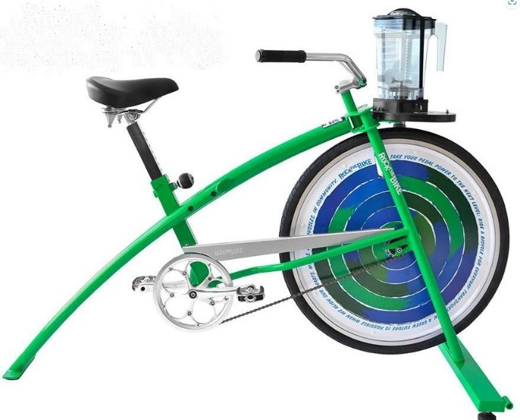

|  |  |  |  |
| --- | --- | --- | --- |
| **BIKE CONDITION ON RETURN** | | | |
| **Item:** | **Condition:** | | **Please tick** |
| **Frame** | Clean, no scratches | | Yes 󠄃󠄃 No 󠄧󠄃 |
| **Wheels/Cover** | Clean, intact, no marks, indents or scratches | | Yes 󠄃󠄃 No 󠄧󠄃 |
| **Seat** | Clean, intact | | Yes 󠄃󠄃 No 󠄧󠄃 |
| **Handles/Pedals** | Clean, intact | | Yes 󠄃󠄃 No 󠄧󠄃 |
| **Blender Bag** | Contains   * 2 x Blenders – Clean (2 x containers, lid and lid insert) * Blender Bike Instructions * Blender recipe suggestions | | Yes 󠄃󠄃 No 󠄧󠄃 |
| **Notes:** | | | |
| *I certify that the Blender Bike is returned by myself and it is in good, clean intact condition as per agreed hire terms and conditions.* | | | |
| **Date Returned:** | | **Time:** | |
| **Hirer Name:** | | **Signature:** | |
| **Officer Name:** | | **Signature:** | |
| Please circle below any damage or issue noticed on return. | | | |





